**18-01-2018**

**RESEARCH INFOTECH**

**DAILY ANALYSIS**

|  |
| --- |
| http://researchinfotech.co.in/storage/images/logo.pngImage result for SEBI |

|  |
| --- |
| **RELCAPITAL (RELCAPITAL) (NSE Cash)** |

|  |  |  |
| --- | --- | --- |
| **BUY** | **562-563** | **SL-545** |
| **TGT 1- 575** | **TGT 2- 595** | **SL-545** |

|  |  |  |  |  |
| --- | --- | --- | --- | --- |
| **S1** | **S2** | **PP** | **R1** | **R2** |
| **535** | **540** | **560** | **575** | **610** |

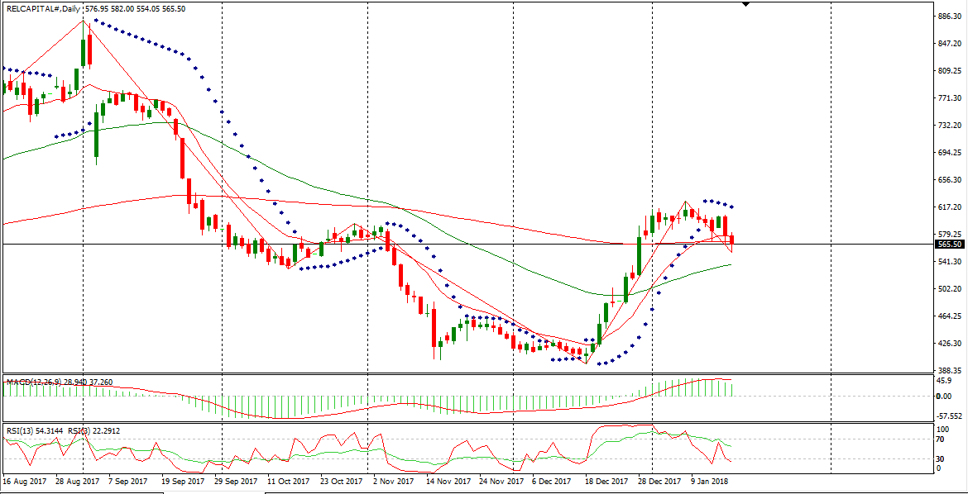

**DESCRIPTION**

Reliance Capital Limited is a non-banking financial services company. The Company has interests in asset management and mutual funds, pension funds, life and general insurance, commercial finance, home finance, stock broking services, wealth management services, financial products distribution, asset reconstruction and other activities in the financial services sector. The Company's segments include Finance & Investments, which includes the corporate lending and investment activities; Asset Management, which includes asset management activities, including mutual fund and portfolio management services; General Insurance, which includes the general insurance business; Life Insurance, which includes the life insurance business; Commercial Finance, which includes the consumer finance and home finance businesses, and Others, which includes other financial and allied services. It also offers mortgages, small and medium enterprises (SME) loans, vehicle loans and infrastructure loans.

|  |
| --- |
| http://researchinfotech.co.in/storage/images/logo.pngImage result for SEBI |

**TECHNICAL VIEW**

* In daily candle RELCAPITAL was taking support of its day’s low and looking bullish.
* In short term candle stick it made a BULLISH HAMMER chart pattern, and its short term structure was looking bullish.
* After making three bearish break away in 15 minute candle stick chart pattern it made a bullish candle, I am expecting it can be gap up for next trading day.
* In daily candle it was taking suppport of its day’s low also
* Near closing I saw continuous buying with huge OI in RELCAPITAL.

**RECENT NEWS**

* Needle Action Activity Spotted in Reliance Capital Limited (RELCAPITAL.NS) as Shares Move -2.75%
* Shares of Reliance Capital Limited (RELCAPITAL.NS) is moving on volatility today -2.75% or -15.90 from the open. The NSE listed company saw a recent bid of 562.25 on 2301530 volume.
* Reliance Capital Limited (RELCAPITAL.NS) has a 14-day ATR of 25.70. The Average True Range is an investor tool used to measure stock volatility. The ATR is not used to figure out price direction, just to measure volatility. The ATR is an indicator developed by J. Welles Wilder. Wilder has developed multiple indicators that are still quite popular in today’s investing landscape. The general interpretation of the ATR is the higher the ATR value, the higher the volatility.
* Moving averages can help spot trends and price reversals. They may also be used to help find support or resistance levels. Moving averages are considered to be lagging indicators meaning that they confirm trends. A certain stock may be considered to be on an uptrend if trading above a moving average and the average is sloping upward. On the other side, a stock may be considered to be in a downtrend if trading below the moving average and sloping downward. Shares of Reliance Capital Limited (RELCAPITAL.NS) have a 7-day moving average of 589.25. Taking a glance at the relative strength indictor, we note that the 14-day RSI is currently at 54.50, the 7-day stands at 40.78, and the 3-day is sitting at 19.53.

## **DISCLOSURE**

RESEARCH INFOTECH DO NOT RECEIVE ANY CONSIDERATION BY WAY OF REMUNERATION OR COMPENSATION OR IN ANY OTHER FORM WHATSOEVER, BY US OR ANY OF OUR ASSOCIATES OR SUBSIDIARIES FOR ANY DISTRIBUTION OR EXECUTION SERVICES IN RESPECT OF THE PRODUCTS OR SECURITIES FOR WHICH THE INVESTMENT ADVICE IS PROVIDED TO THE CLIENT.

RESEARCH INFOTECH DO NOT RECOMMEND A STOCK/COMMODITY BROKER. IF ANY STOCK/COMMODITY BROKER IS RECOMMENDED BY ANY OF OUR REPRESENTATIVE, WE DO NOT RECEIVE ANY CONSIDERATION BY WAY OF REMUNERATION OR COMPENSATION OR IN ANY OTHER FORM WHATSOEVER FROM STOCK/COMMODITY BROKER OR ANY OTHER INTERMEDIARY SO RECOMMENDED TO CLIENT.

TO ENSURE COMPLIANCE WITH THE INVESTMENT ADVISOR REGULATIONS 2013, WE HAVE RESOLVED THAT THE INVESTMENT ADVISOR AND ALL ITS REPRESENTATIVES WILL NOT MAKE ANY TRADES IN THE MARKET. WE ARE NOT ASSOCIATED IN ANY MANNER WITH ANY ISSUER OF PRODUCTS/ SECURITIES, THIS ENSURES THAT THERE IS NO ACTUAL OR POTENTIAL CONFLICTS OF INTEREST. THIS ALSO ENSURES THAT OBJECTIVITY OR INDEPENDENCE IN THE CARRYING ON OF INVESTMENT ADVISORY SERVICES IS NOT COMPROMISED. INVESTMENT IN STOCK/COMMODITY MARKETS IS SUBJECT TO MARKET RISK, THOUGH BEST ATTEMPTS ARE MADE FOR PREDICTING MARKETS, BUT NO SURETY OF RETURN OR ACCURACY OF ANY KIND IS GUARANTEED, WHILE THE PERFORMANCE SHEET OF VARIOUS PRODUCTS IS AVAILABLE BUT SHOULD NOT BE CONSIDERED AS A GUARANTEE FOR FUTURE PERFORMANCE OF THE PRODUCTS/SERVICES. CLIENTS ARE ADVISED TO CONSIDER ALL THE ADVICE AS JUST AN OPINION AND MAKE INVESTMENT DECISION ON THEIR OWN.

IN CASE OF CLIENTS SEEKING ADVICE ON ANY SPECIFIC POSITIONS ALREADY MADE BY THE CLIENT, WE WILL BE ABLE TO SUGGEST BEST POSSIBLE ACTION CONSIDERING OUR VIEW ON THE SECURITY OR PRODUCT. SUCH SUGGESTION UNDER ANY CIRCUMSTANCES SHALL BE CONSIDERED AS AN OPINION (NOT ADVICE) FROM OUR ORGANIZATION AND WE ADVISE CLIENT TO CONSIDER OUR OPINION AND NOT CONSULTANCY TO MAKE HIS/HER FINAL DECISION. WE ARE NOT LIABLE FOR ANY LOSSES WHATSOEVER CLIENT MAY INCUR IN ACCEPTING THIS OPINION.

CLIENT IS ALSO ADVISED TO TRADE ONLY IF TIPS SUIT HIS CURRENT RISK APPETITE AND RISK BEARING CAPACITY, ALL SUCH TIPS SHALL BE CONSIDERED AS A VIEW OR OPINION AND CLIENT SHALL ON HIS/HER DISCRETION DECIDE ACTUAL TRADES.

WE ARE NOT ASSOCIATED WITH ANY INTERMEDIARIES AND DO NOT RECOMMEND SERVICES OF ANY SPECIFIC INTERMEDIARIES.  
NO LITIGATIONS HAVE BEEN FILED AGAINST US SINCE THE INCORPORATION.

ALL THE TIPS WHICH ARE SUGGESTED BY US ARE COMMUNICATED IN WRITTEN, NO VERBAL COMMUNICATION FROM ANY OF THE EXECUTIVES OR OTHERWISE UNDER ANY CIRCUMSTANCES SHALL BE CONSIDERED AS ADVICE BY OUR ORGANIZATION.